Experiment 0 Documentation

Tools required:

1. The HaHa v3.0 Board.

2. A USB A-to-B cable

3. Laptop

Software used:

1.GOWIN FPGA

2.Microchip Studio

3. Atmel FLIP

4. An oscilloscope or Analog Discovery (AD) Board a. Optional – Waveforms 2015 to view AD board signals

Process:

Part I:

The initial phase was starting by downloading all the software’s given in the website which was already provided in the laptop. To start off the experiment, I connected the provided USB cable to my laptop and connected to the J14 port in the HAHA board.

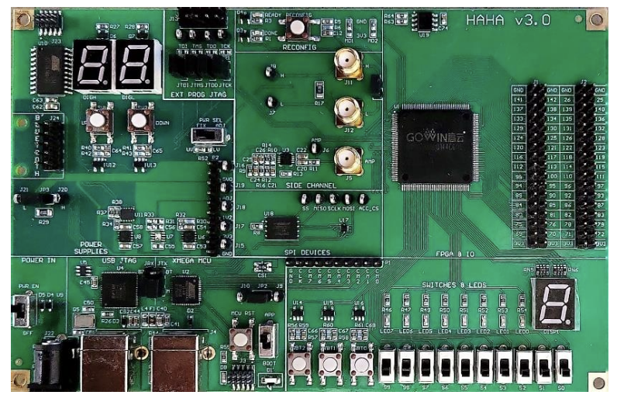



Image 1: J14 port is the one which is circles.

After the board was connected to the laptop, the next step was to turn the board on. To turn it on I just pushed the button to turn on.

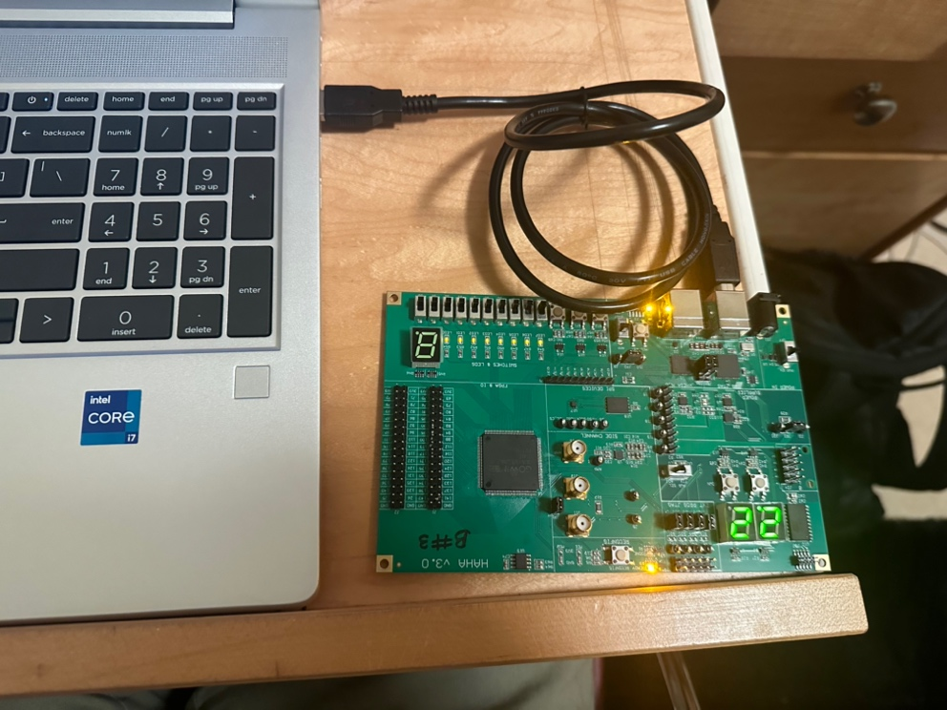

Image 2: After the board was turned on

I tried using the Analog Discovery board and Waveforms to check the voltages along the pins, but my waveforms was not working for some reason so I was not able to test out this part.

After trying everything, I moved on to change the “PWR SEL” to “FIX” which helps us to program both chips successfully.

Part II:

The board was still connected to the computer. The next step is to open up the GOWIN FPGA Designer and go to tools and navigate to programmer which can be found in the menu bar on top left. We just make sure the Port is set to “Gowin USB Cable(FT2CH)/0/…” Click on the Find Device button (first button below menu bar that has a magnifying glass). Then double click on the option called GW1N-9C. A new entry will now show up on the first row. Double click on Read Device Codes and change the following settings and then Press Save:

a. Access Mode = Embedded Flash Mode

b. Operation = embFlash Erase,Program,Verify

c. File name = <location/of/the/self_testfpga> (as given in the powerpoint)

After waiting for some time, the board started lighting up. The 8 LED lights started working.

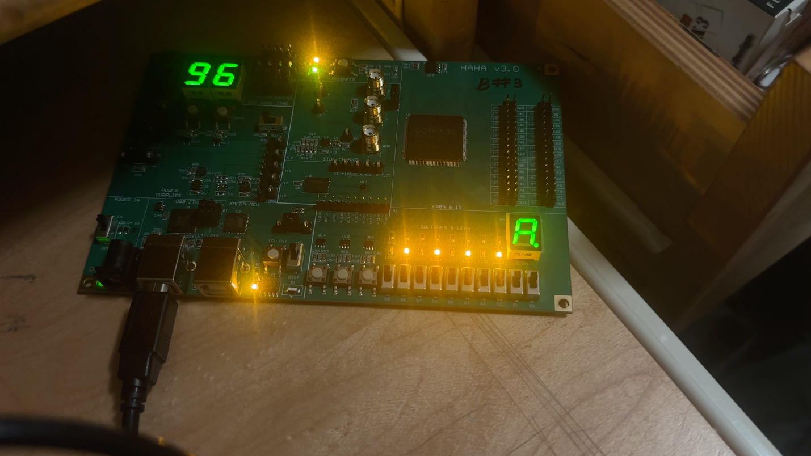

Video: LED’s working and changing patterns

Part II

A.1 What are the two led patterns occurring in the board?

The two LED patterns occurring in the board are: one is the light alternates between led’s leaving one of the off and so on and the second pattern is it moves in a line from one point to the other point.

A.1.B. Which patterns of the switches trigger either of the LED patterns?

When all the LED switches are turned up, it flickers and alternates between the LED’s as the first pattern mentioned. When S0 is turned down it changes into the second pattern, When S1 is also pulled down it goes back to its first pattern. The pattern follows one after another rule where it does not really care what the switch triggers. All the witches just change from one pattern to the other one.

B. What happens to the digit on the 7 segment display when you keep pressing any of the buttons?  
When pressed any of the three buttons, it shows a 0 on the 7 segment display while pressing any buttons but the way it displays the zero flickers in different segment everytime the button is pressed.

C.

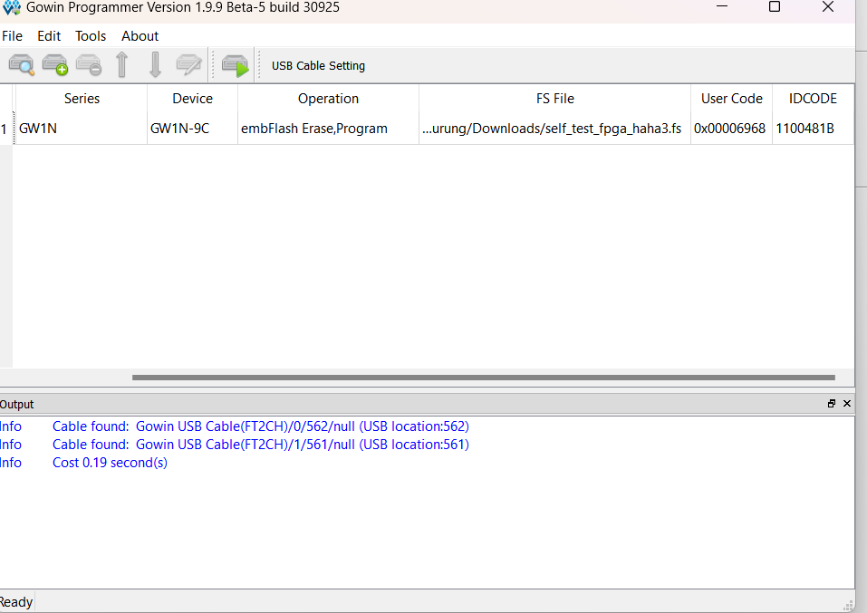

D.

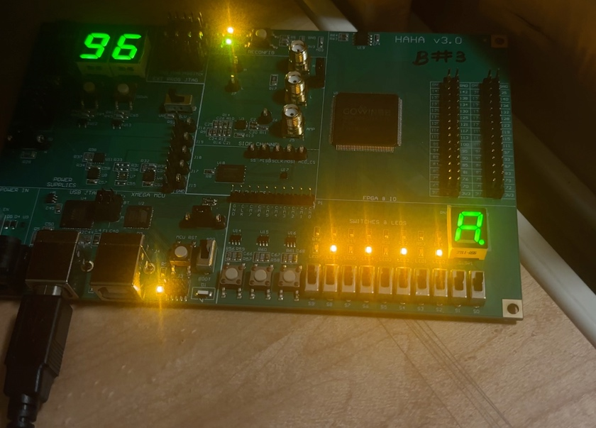

Part III:

For the third part. I turned off the circuit board and switched up the ports in the circuit board from J14 to J4.





Image : J4 port on the board, Boot and MCURST

After Switching up the ports, I turned on the board again. Switched the button. From App to Boot and the pressed the MCU RST button multiple times before the lights stopped flickering.

After that I opened up Microchip studio to detect the microcontroller. To do that we navigate to Tools > Device Programming in the menu bar. Alternatively, you can press Ctrl + Shift + P to open the same window. Select Atmel FLIP for Tool and ATxmega16A4U for Device. Click Apply, then press Read under the Device Signature. After that the application can be closed.

The next is to open Atmel Flip and click the leftmost button under the File menu (called Select a Target Device). Select ATxmega16A4U and press OK. Then, click the second button with the USB icon. Select USB (Ctrl + U). Press Open on the next window. Go to File > Load HEX File… menu. Navigate to the location of the provided file (U_ACC.hex). Click OK, then press Run. For more information, you can refer to the XMega Microcontroller Guide for HaHa v3.0 Board document.

This helps the microcontroller to read the acceleration data from the accelerometer and send it to the FPGA. TO do that we must put the LED’s. in 1001 order when the first and fourth button are up but the second and third button are down.

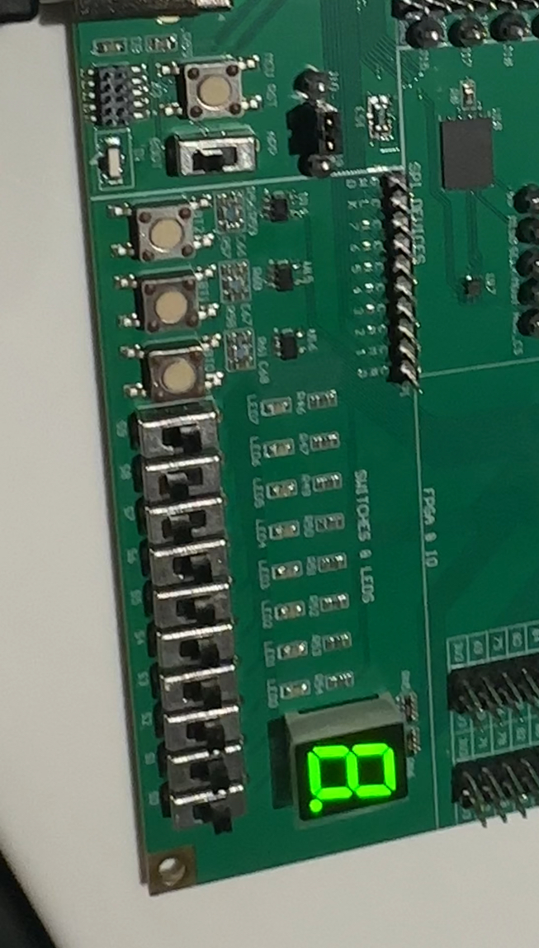

Image: Button in 1001 format

After hitting the MSU RST button for multiple times again the LED’s started working. Whenever the board was moved. Slightly the LED’s changed its values accordingly.

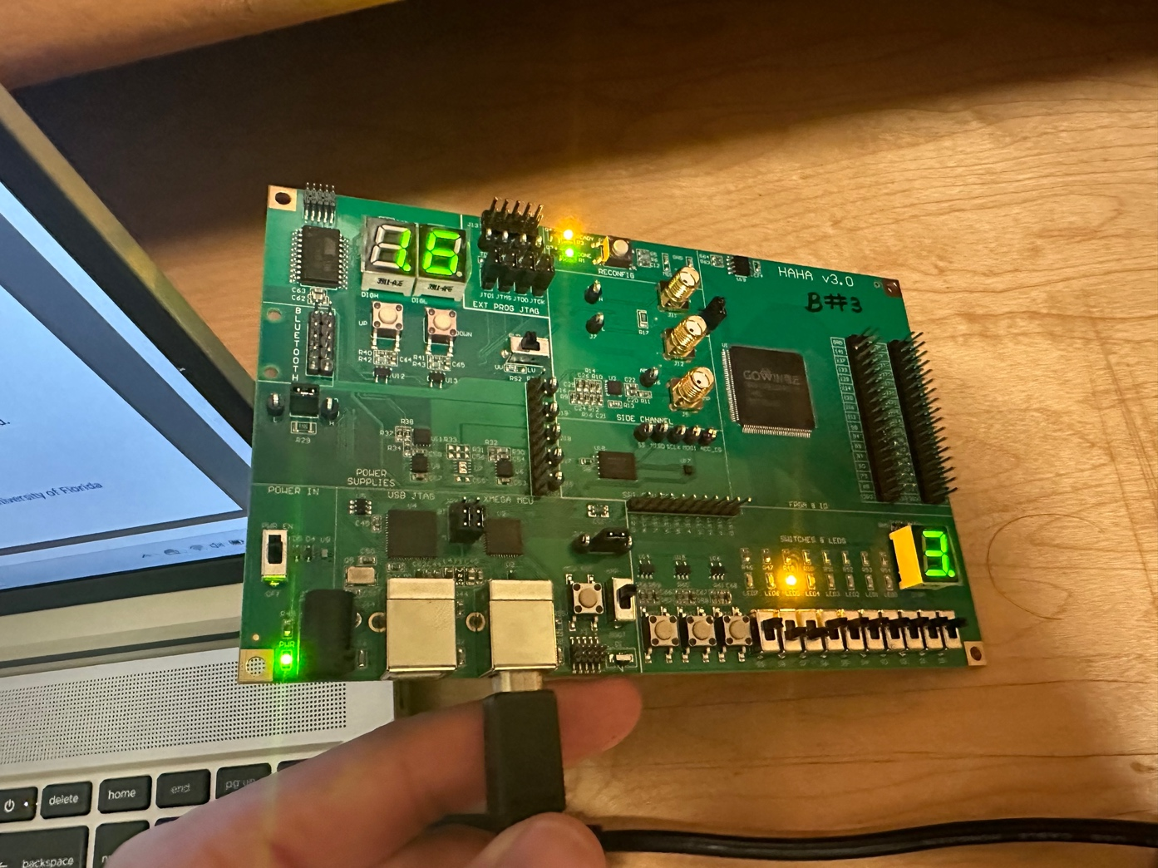

Image : Acceleration value

For the next process I opened GOWIN FPGA Programmer. Go to File > New. Select FPGA Design Project. Name the project haha3_self_test with the directory of your choosing. In the device selection window, use the following filters:

• Series: GW1N

• Device: GW1N-9

• Device Version: C

• Package: LQFP144

• Speed: C6/I5

I did all of the process from selecting the Part Number: GW1N-UV9LQ144C6/I5.

The project creation process is just needed to unlock the GOWIN Analyzer Oscilloscope (GAO) tool. Go to Tools > Gowin Analyzer Oscilloscope. Press the folder button. Navigate to the location of the provided file (self_test_fpga_haha3.rao) and click Open. Check Enable Programmer. Press the button with the magnifying glass. Select GW1N-9C. Check the box below Enable. Under Fs File, click the empty field. Navigate to the location of the provided file (self_test_fpga_haha3.fs).

Press the small green play button (under Enable Programmer) to program the FPGA. After successfully programming.

The final part was to press the F2 key, and when I pressed it, nothing changed. So this was not achievable too.

Part IV:

The next aprt was to test the temperature. The process was the same from making the microcontroller known from microchip to using the Atmel flip to code the board. The only different process was the switches for which S6 to S9 was set to 1001 this time.

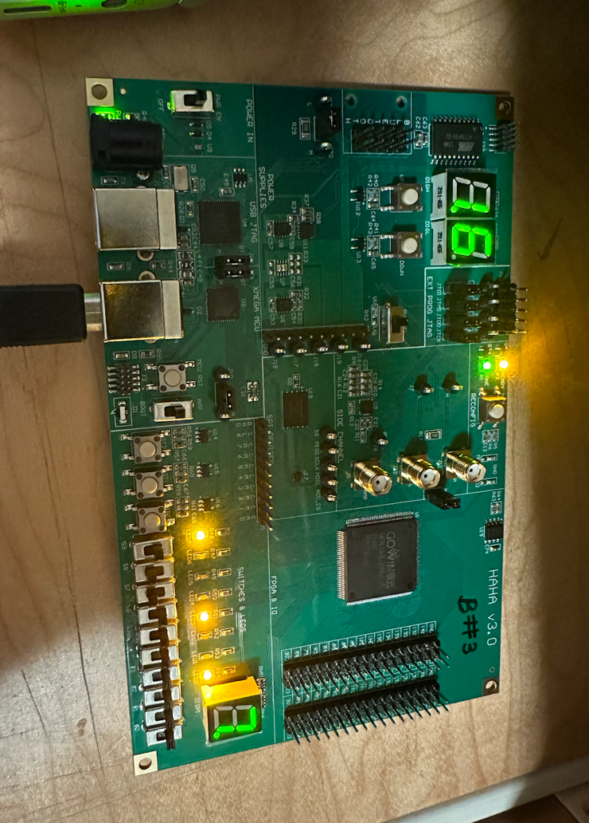

Image : After programming (U_TEMP.hex) using Atmel Flip

GOWIN Analyzer Oscilloscope did not show the aforementioned signals as stated before.

Part V:

The last part was the same Part IV where I programmed the microcontroller using U_FLASH.hex file and the LEDs showed 00101001.

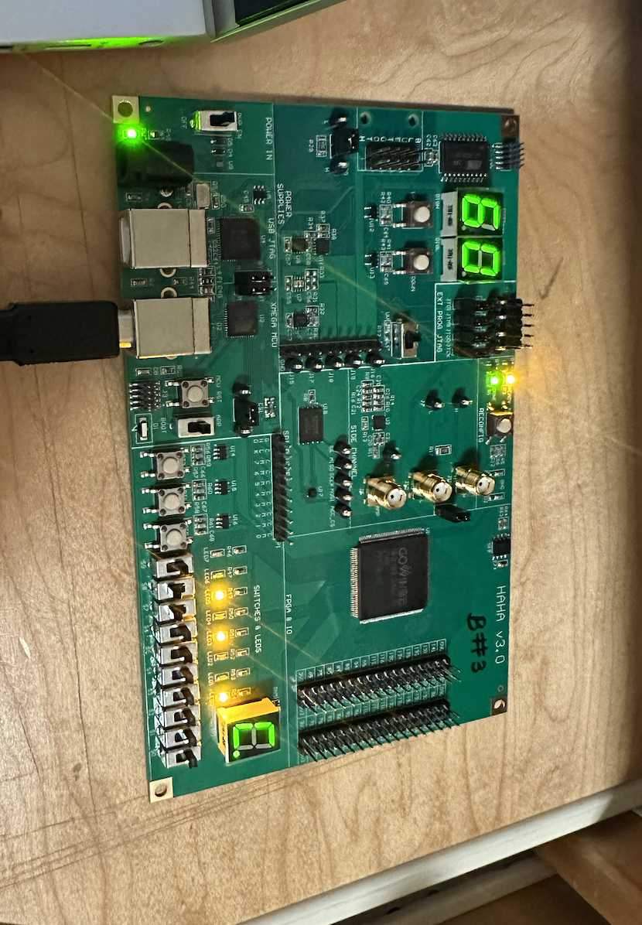

Part VI: Feedback

1.What problems have you met when doing the tests? How did you solve them?

- There were a lot of places where the information was not provided properly, and I did not know what I was doing. Sometimes choosing the given options didn’t work and instead choosing the alternate option worked. I took help with some friends and tried to solve them but some of them were just not working for some reason like the Analog Discovery Oscilloscope.

2. What suggestions do you have to make the test process easier and more friendly to students?

- To make it more friendly and easier for students, I believe the process should be layed out properly because the PowerPoint we were provided was a lot more confusing. Especially as a beginner not knowing anything and working on it felt more confusing cause I did not know what was doing once I got stuck.